**Lab 02 - Perform an on-demand refresh**

Now that you've configured a refresh schedule, Power BI refreshes your dataset at the next scheduled time, within a margin of 15 minutes. If you want to refresh the data sooner, such as to test your gateway and data source configuration, perform an on-demand refresh by using the **Refresh Now** option in the dataset menu in the nav pane. On-demand refreshes don't affect the next scheduled refresh time, but they count against the daily refresh limit, mentioned in the previous section.

For illustration purposes, simulate a change to the sample data by updating the DimProduct table in the AdventureWorksDW database using SQL Server Management Studio (SSMS).

SQLCopy

UPDATE [AdventureWorksDW2020].[dbo].[DimProduct]

SET ListPrice = 6000

WHERE EnglishProductName ='Road-250 Red, 58'

Now follow these steps so the updated data can flow through the gateway connection to the dataset and into the reports in Power BI.

1. In the Power BI Service, in the nav pane, select and expand **My Workspace**.
2. Under **Datasets**, for the **AdventureWorksProducts** dataset, select the ellipsis (**. . .**) then select **Refresh now**.

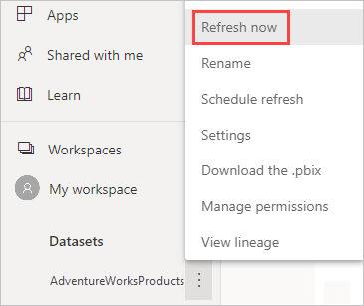

Note in the upper right corner, that Power BI is preparing to perform the requested refresh.

1. Select **My Workspace > Reports > AdventureWorksProducts**. See how the updated data flowed through, and the product with the highest list price is now **Road-250 Red, 58**.

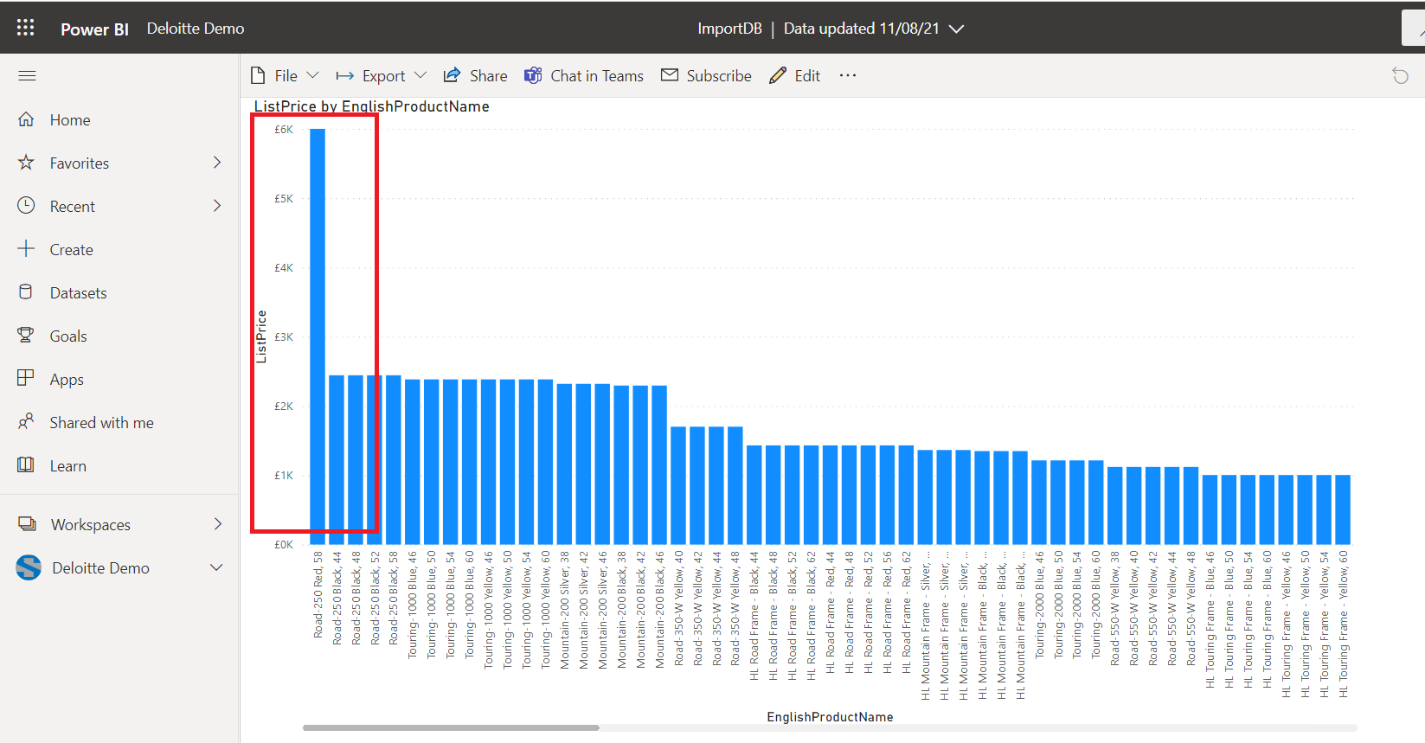

**Review the refresh history**

It is a good idea to check the outcomes of past refresh cycles periodically in the refresh history. Database credentials might have expired, or the selected gateway might have been offline when a scheduled refresh was due. Follow these steps to examine the refresh history and check for issues.

1. In the upper-right corner of the Power BI user interface, select the settings gear icon and then select **Settings**.
2. Switch to **Datasets** and select the dataset, such as **AdventureWorksProducts**, you want to examine.
3. Select the **Refresh history** link to open the **Refresh history** dialog.

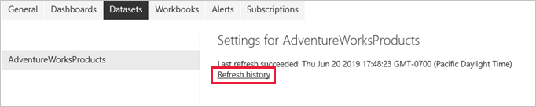

1. On the **Scheduled** tab, notice the past scheduled and on-demand refreshes with their **Start** and **End** times, and a **Status** of **Completed**, which indicates that Power BI performed the refreshes successfully. For failed refreshes, you can see the error message and examine error details.

